**Mathopoly**

**Perspective**

You, a math student, turned math history enthusiast, want to grow your collection of artifacts and original math papers. There is, however, competition. Others alike tussle to be the first ones to the relics. Through this, you play a game of chance, finances, and strategy in order to grow your own collection as you diminish the competition’s.

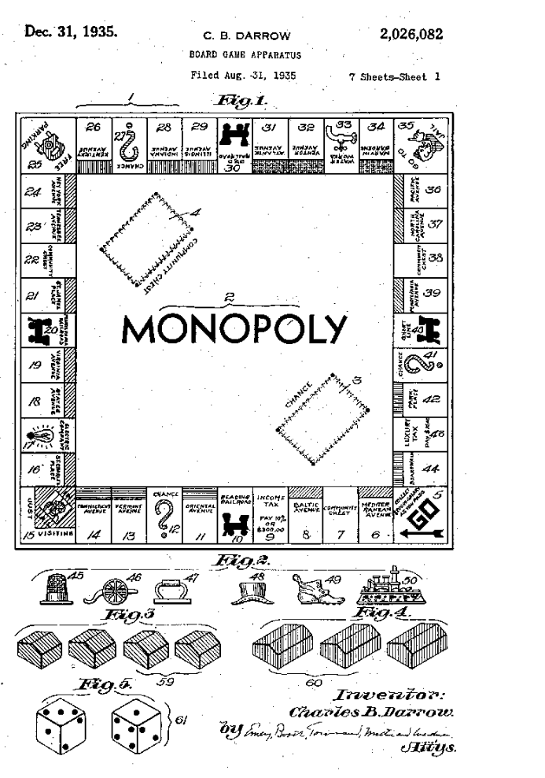

**General Rules**

* 2 to 8 players can play. One of the players must be the Bank (actively playing or not), and therefore in charge of handling the money
* Negotiations and trades are allowed. Unless the majority vetoes
* If a dice throw gives 0 (black die: x=2, blue die: x^2 - 4) a player has to throw again
* Players start with 1000€ and get 200€ every time they go through the Go arrow
* When players land on an unowned relic, they can buy it, and if running out of money, they can rent it out.
* Players who land on owned relic must pay a fee to the owner
* Owning a whole color set enables the purchase of Badges, which further increases the price of the relic
* When a relic has 4 Badges of Authenticity (BoAs) a Certificate of Authenticity (CoAs) can be purchased, which confirms a relic’s indisputable legitimacy, thus increasing its price
* Luck slots may benefit or damage a player and their collections
* An EQ slot requires a player to answer an Exercise Question, If answered correctly they get 400, if not they lose 400. An answer must be given until their next turn or at 5 minutes.
* A TQ slot requires a player to answer a Theoretical Question, If answered correctly they get 200, if not they lose 200
* Players in jail can get out by paying 100, using special get-out-of-jail cards, or by getting a 0 from the dice throw before 3 of their turns
* Only one membership is available for each of the 4 Societies of Appraisers. The more memberships a player has, the higher the fees become
* A game goes on until every player but one cannot pay what they owe or negotiation is made to end the game with one sole winner

Original Monopoly rules: <https://www.solitaireparadise.com/games_list/monopoly.html>

**Which Dice will we use?**

(blender 3d model on the left)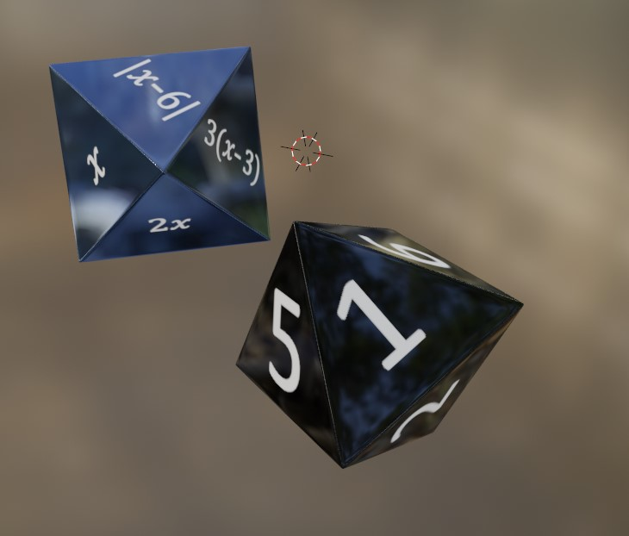

* 2 8-sided dice
* A black die with values for x and a blue die for functions with x.
* Example: if the black die lands on 4 and the blue die lands on x^2, the player must take 16 steps
* The amount of steps players have to take is determined by the answer to the equation made with the two dice.

**How is the money going to work?**

* Similar to the original monopoly
* Currency is Euros
* Bank rules are stated below.

**BANK**:

* The bank works as a mediator for selling relics, giving it the ability to sell the relics listed below. They hold the relic cards until purchased by a player.
* They sell Badges of Authenticity and Certificates of Authenticity to the players.
* The bank also loans money when required.
* Unlicensing a relic (mortgaging) can be done so by the bank when needed.
* The bank never becomes insolvent. They can always issue cash by writing on ordinary paper.

**UNLICENSED RELICS:**

* To unlicense a relic, you must first sell all BoAs and CoAs on said Relic’s Color set at half price to the Bank.
* In order to unlicense, the player must turn the relic card face down and collect the unlicensing value on the back of the card from the bank.
* In order to regain your license, pay the licensed cost to the bank (unlicensed value + 10%), then turn the relic card face up.
* If a player lands on an unlicensed relic, they cannot be charged for it. However, increased charges can be collected from players who land on licensed relics in the same color set.
* Increased charges on Societies of Appraisers that the player owns may also be collected the same way.
* You cannot develop an Unlicensed relic. However, the relic may still be sold to another player. This new player can now license the relic by paying the {unlicensing amount + 10%} or later by paying {unlicensing amount + 20%}.

**BOARD**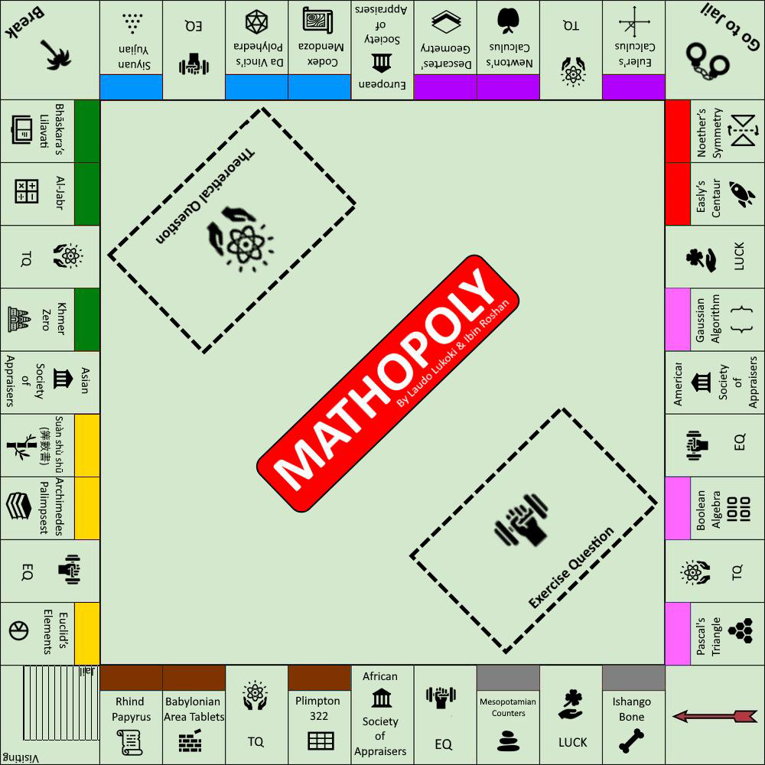

**Dimensions**

* 20x20in/ 50x50cm
* Customized slots

**Properties & color sets:**

<https://mathigon.org/timeline>

* 1. Stone Age (gray): Ishango Bone, Mesopotamian Counters
* 2.Bronze Age (Bronze): Babylonian Tablet (Plimpton 322), Babylonian Area Tablets, Rhind Papyrus
* 3.Classical Age (yellow): Euclid’s Elements, Archimedes Palimpsest, Suàn shù shū (筭數書),
* 4. Middle Ages (green): Khmer Zero, Muhammad Al-khwarizmi's Al-Jabr, Bhāskara’s Lilavati
* 5.Renaissance (blue): Siyuan Yujian by Zhu Shijie, Da Vinci's Polyhedra, Codex Mendoza
* 6.Enlightenment (purple): Descartes's Analytical geometry, Newton's Calculus, Euler's Calculus
* 7. Modern (red): Noether’s Symmetry, Easley’s Centaur,
* 8. Honourable Mentions (pink): Gaussian Algorithm, Boolean algebra, Pascal’s Triangle

Companies & Institutions: American Society of Appraisers, African Society of Appraisers, Asian Society of Appraisers, European Society of Appraisers

Possible pieces: calculator, piece of pie, Hand with right-hand rule, abacus, protractor, chess piece, compass, golden ration shell, Alchemdes’ screw,

**Membership Cards**

Memberships work similarly to the companies in the original monopoly game. Only one person can have them, and the more you have, the higher the fees are. Since this game revolves around building and increasing the value of one’s own collection, it makes sense to join an institution that has the ability to do just that: upraise the value of relics and original documents. Also, while owning a company as a student can feel unrealistic, having memberships feels much more adequate.

**Card Deck**

* 4cmx8cm for the color and institution slots and 8cmx4cm for questions and luck cards



African

Society of

Appraisers

Fee: 50€

Fee with 1 membership: XXX

Fee with 2 membership: XXX

Fee with 3 membership: XXX

Fee with 4 membership: XXX



Exercise Question

x=2+3i and y=1−i

Express the Polar Form of z=xy



Theoretical Question

What is the Fundamental Law of Algebra?



LUCK

Move 3 steps forward.



**Luck cards**

Luck cards are situational cards that work similarly to the Community Chest and Chance cards in the original monopoly game. They either require you to move slots or present situations in which you either gain or lose money.

Examples:

* Experts admire your collection, you get 10€ for each relic you own
* Experts question the legitimacy of your collection, pay 10€ for each relic you own
* You get a Jail Free card, which you can use next time you are imprisoned
* You tried to forge fake documents for your relics, go to jail!
* You made a room with low temperature and low humidity to store relics, pay 200€
* You forgot to pay shipping taxes, you must pay 20€
* Your “Relic Informant” charges you for their services, pay 50€
* Move 3 steps forward
* Move 4 steps back
* Memberships have a rewards system, get 10€ for every membership
* You look tired, go take a rest
* Membership is costly, pay 100€ per Appraisers membership you have
* Delegating is an important skill, choose a person to answer your next TQ or EQ

Exercise Question Cards

* Solve SLE:

4a − 6b + c = 1

2a − b + c = 5

−6a + 3b − 2c = − 3

a= -31/8 b=-3/4 c=12

* Solve SLE:

3x + y - z = 1

x - y + z = -3

2x + y + z = 0

x= -1/2 b=7/4 c=-3/4

* x=2+3i and y=1−i. Express the Polar Form of z=xy

z=sqrt(26) e^(i phi(1/5))

* x=1 is a solution. Find roots of z = x^4 + x^3 + x^2 + 3x − 6

x=1, x=-2, x=sqrt(3i), x= -sqrt(3i)

* v1=(3,4,2); v2=(3,2,1); v3=(7,10,0); v4=(2,2,3). Calculate (v1v3)v2

-30

* v1=(3,4,2); v2=(3,2,1); if v1 is the tension force and v2 is direction, calculate the resultant force projected on v2.

19/sqrt(14)

* A plane has points A:(1,3,4) B:(5,5,5) C:(4,7,4). Express its equation in the normal and coordinate forms.

n= (-4 3 10) n∙[(x y z)-(1 3 4)]=0 −4x + 3y + 10z = 45

* Find

1/7

* Find

-2

* Compute and give its domain

(2x^2(x+6))/(x+4)^2

* Find antiderivative

F(x) = sin(3x + 2) + c

Theoretical Question Cards

The given answers are only templates and anything that relates to the sample answers counts.

* What is the Fundamental Law of Algebra?

A polynomial to the nth degree has n nth roots

* What is Heron’s Method?

Method of approximating square roots

* What did Complex Numbers allow for in terms of the number System?

Allowed for the expansion of the number system into a new dimension

* What is a Pivot in SLE?

The first non-zero element of each row

* When does an SLE not have solutions?

When a pivot is on the RHS

* When does an SLE have infinite solutions?

When there is a pivot-free column on the LHS

* When does an SLE have unique solutions?

When there is exactly 1 pivot per column on the LHS.

* When is an SLE in row-echelon form?

When pivots on the LHS are positioned diagonally, top left to bottom right.

* What does the exponentiation of Complex numbers do graphically?

Scales the radius and rotates.

* Name 3 scalar and 3 vector quantities

Scalar: Speed, distance, mass, etc. Vector: Displacement, velocity, force, etc.

* Which mathematical algorithm converts a Plane equation from coordinate to parameter form?

Gaussian Elimination

* When is the Dot Product 0?

When the vectors are perpendicular

* When is the Cross Product 0?

When the vectors are parallel

* When is a function continuous?

f(x) is defined, its limit exists, and f(x) = limit of f at x

* What is Fermat’s Theorem in calculus?

If f has an extremum at x=c, and f’(c) exists, then f’(c)=0

* What is the first part of the Fundamental Theorem of Calculus?

For a continuous function f, where g exists and is defined as a variable integral in the same interval, then g’(x)= f(x)

* What is the second part of the Fundamental Theorem of Calculus?

For a continuous function ƒ from 𝘢 to 𝘣, there is an antiderivative 𝘍 from a to b, 𝘍(𝘣)-𝘍(𝘢).

* What is a Critical Point in curve sketching?

A possible extremum, where a function’s rate of change changes signs

* What is a Point of Inflection in curve sketching?

Points where the graph of a function changes concavity